php upgrade 8.1 to 8.4
Tuesday, March 11, 2025
2:48 PM

Two installations.

- as part of xampp

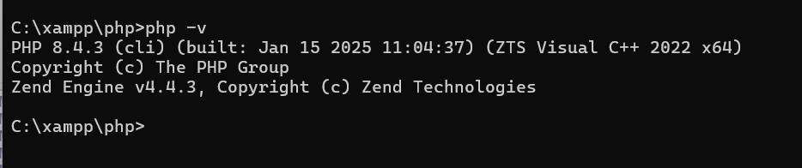

- as part of standalone.
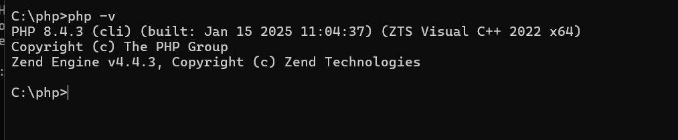

ISSUE: latest version of xampp as of 03/11/2025 comes with php 8.1 (which has some critical vulnerabilities).

Hi Ashok, could you please look into updating PHP on your WellSky workstation to version 8.3.14 or newer. There is a critical severity vulnerability in the version you have installed on your WellSky workstation (WSKY-7DDN7C3) and InfoSec is looking to get it patched.

To upgrade:

- Take backup of php 8.1 folder in c:\xampp and copy php 8.4 to xampp folder. Rename it to php.
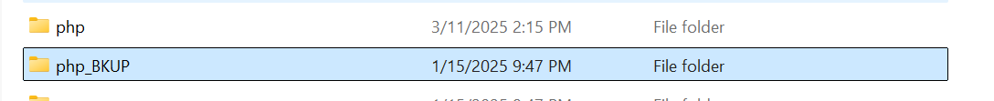

- Update php.ini to match with php8.1.init
(modules and other path related settings)

- Get the x64- thread-safety version of oci 19 from pecl link for php 8.4 (download to ext folder)

https://pecl.php.net/package/oci8/3.4.0/windows

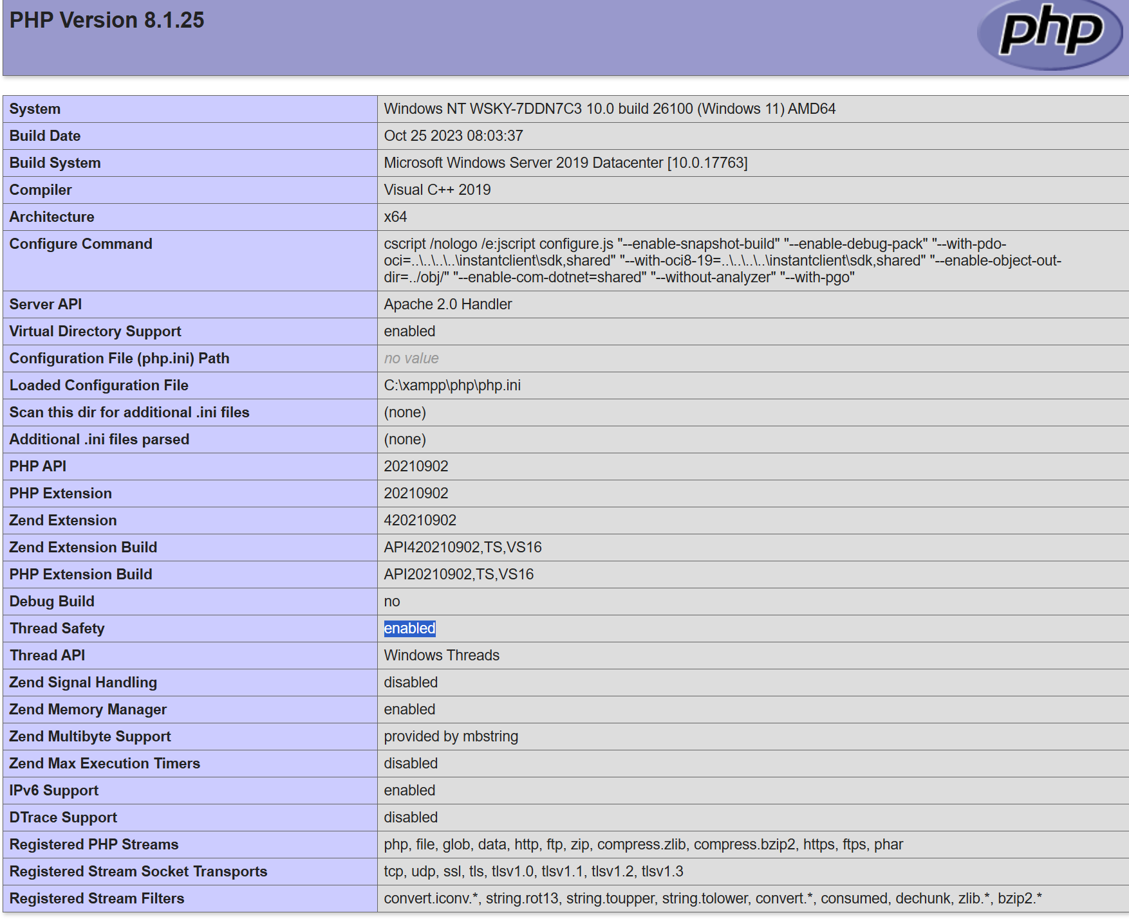

- do php -v

- check the app. I noticed that curl does not work. And upon further verification, found that the curl module is not loaded.

- Verified that the dll ext is present in ext folder.

- As per the below link. https://github.com/php/php-src/issues/16942

copying libssh2.dll from php84 to the Apache bin folder solved the issue for me.
